Experiment 15:
Source code :
#include <reg51.h>
void main()
{
unsigned int hex_num = 0x1F4;
unsigned char hundreds, tens, ones;
/* Convert hexadecimal value to decimal digits */
hundreds = hex_num / 100;
hex_num = hex_num % 100;
tens = hex_num / 10;
ones = hex_num % 10;
/* Display digits on ports */
P0 = hundreds;
P1 = tens;
P2 = ones;
while(1);
}
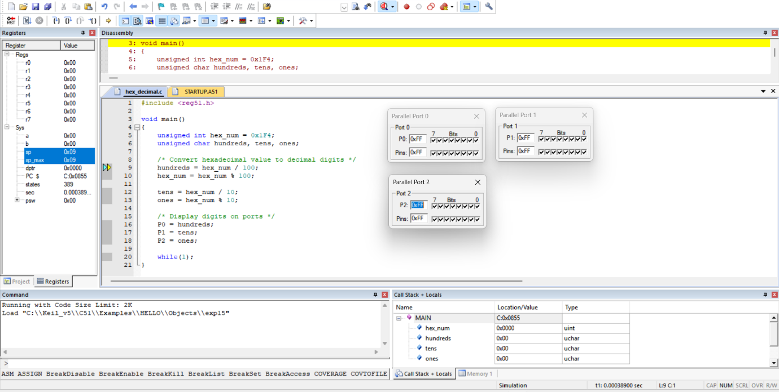
output :

